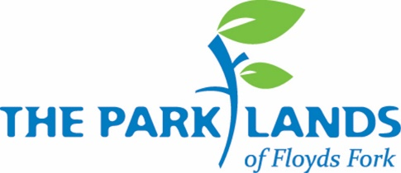

Development Manager

The Parklands seeks a highly organized individual passionate about parks, the outdoors, and fostering a community that supports this visitor−and-donor supported park through financial contributions of all sizes. The Development Manager will be an integral part of the Development team, reporting to the Vice President of Development and Administration, and will play a key role in supporting major fundraising events as well as the recruitment and stewardship of donors essential to sustaining The Parklands of Floyds Fork.
Primary Responsibilities:
- Work with the Vice President of Development and Administration to coordinate and plan The Parklands’ Annual Fund campaign
- Assist with and lead the planning of major fundraising events annually
- Manage event sponsorship applications, outreach, and sales
- Plan Membership programs and stewardship events
- Coordinate all aspects of grant writing, including research, drafting, and submission, to maximize funding opportunities
- Work with individuals, foundations and businesses to raise awareness
- Work closely with our Communications team to ensure proper promotion around fundraising and membership programs, renewal emails and other digital campaigns
- Other duties as assigned by the Vice President of Development and Administration
Experience / Qualifications:
- Associate or Bachelor’s degree or equivalent professional experience preferred
- Knowledge and experience in fundraising techniques including grant writing and event sponsorship requests
- Excellent interpersonal skills with a collaborative, customer-service attitude
- Experience in overseeing event logistics, implementation, and execution
- Strong organizational and writing skills with the capacity to manage multiple projects simultaneously while maintaining attention to detail
- Experience working independently to achieve individual and team goals; be a self-starter
- Seek opportunities to problem solve and propose creative solutions
- Proficiency in Microsoft Office Suite (Word, PowerPoint, Outlook, etc.)
- Demonstrate professional conduct and attitude at all times
- Some work during evenings and weekends required as related to annual events
- Must have a valid Driver’s License
- Must be able to sit for prolonged periods of time
About The Parklands of Floyds Fork:
The Parklands of Floyds Fork is a systemic, world-class addition to Louisville’s park system that includes four major parks linked by a park drive, a first-rate urban trail system, and a remarkable water trail, all tracing Floyds Fork, a classic Kentucky stream. Ongoing maintenance and operations are funded solely through private donations, earned income and an endowment fund. This public/private project is a unique and truly city-shaping model. This is the largest fully funded non-profit park system in the nation. Learn more at www.theparklands.org.
Job Location:
This position is based in The Parklands of Floyds Fork’s main office.
Compensation and Benefits:
This is a full-time position with a competitive salary and benefits package including health/dental insurance, a 401k matching program, two weeks paid vacation, five sick days per year, and a fun and energetic work environment.
To Apply:
Applications will be accepted until this position is filled. Interested candidates should submit their resume, a cover letter, expected salary, and a list of two references via email to careers@theparklands.org with “Application: Development Manager” in the subject line. Please, no phone calls. Any recommended applicants for hire must pass a background check.

