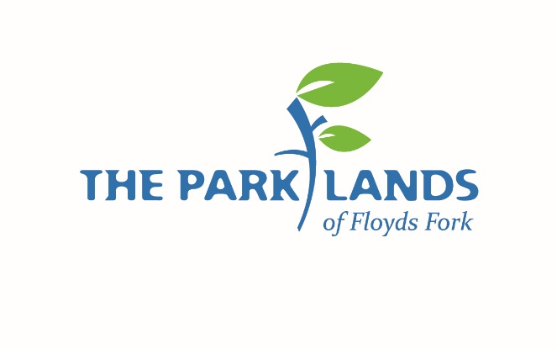

Natural Areas and Trails Technician

**THE PARKLANDS:**

The Parklands of Floyds Fork is a systemic, world-class addition to Louisville’s park system that includes four major parks linked by a park drive, a first-rate urban trail system, and a remarkable water trail, all tracing Floyds Fork, a classic Kentucky stream. 21st Century Parks, a 501(c)3 established in 2004, is responsible for the operations and maintenance of The Parklands of Floyds Fork. This public/private project is unique in the region and unlike anything currently in development across the country—truly a city-shaping model. Learn more at www.theparklands.org.

**SUMMARY:**

The Parklands of Floyds Fork is seeking an energetic, skilled, and hard-working professional with natural lands experience to join our operations team. Our ideal candidate will participate in raising and maintaining the management and design intent of our natural landscapes, trails and conservation programs. Candidates will work alongside the garden and operations team with oversight by the Director of Horticulture and Natural Areas to ensure quality plant and ecological landscape health within our park system.

Natural landscape and trails management has long been an important priority in the continued development of the entire park system. Several projects undertaken by staff and contractors have been completed with support from generous funding programs focused on maintaining wildlife ecology, plant diversity, soil, and water conservation. The focus thus far been on invasive plant removal, restoration plantings, and stream-bank soil erosion management, among others.

**ESSENTIAL DUTIES AND RESPONSIBILITIES:**

PRINCIPAL FUNCTION:

* To support the mission and vision of The Parklands through natural lands management practices to provide a safe, clean, fun and beautiful experience for visitors

RESPONSIBILITIES:

* Execute the “Natural Areas Plan” that outlines necessary critical areas of management and protection that includes invasive plant removal and tree plantings
* Trail work including construction, maintenance and repair
* Assist with contractor oversight for large scale natural area conservation projects
* General landscape horticulture practices such as string trimming/brush cutting, watering/irrigation, weeding, pruning, and planting/transplanting
* Use IPM strategies to combat plant health issues while maintaining ecological and public safety
* Enhance soil health through identifying erosion issues and installation of solutions
* Identify, troubleshoot and assist in addressing a wide range of landscape challenges that affect plant safety issues
* Regularly complete progress work documentation records
* Assist in planning, organization and oversight of volunteer activities
* Maintain clean and organized work areas to ensure safety and proficiency in the workplace
* Train and work with seasonal and intern staff

GUEST SERVICES & OPERATIONS:

* Answer visitor questions and respond to issues
* Provide support of natural lands information to visitors and through public communications such as blog posts
* Assist with general park cleanliness and safety reporting
* Aid in maintaining general park cleanliness, support events, minor turf management, storm clean up, and minor maintenance repairs

The above job duties and responsibilities describe the general nature and level of work for employees in this position, but this is not intended as an exclusive or all-inclusive inventory of all duties required of employees in this job.

**EXPERIENCE, EDUCATION & QUALIFICATIONS:**

MINIMUM QUALIFICATIONS:

An individual must be able to perform each essential duty listed above and any additional responsibilities as directed as well as satisfy the educational and skill requirements listed below.

EDUCATION & EXPERIENCE:

* Training, schooling or practical experience maintaining natural lands that provides required knowledge and abilities.
* Valid Driver License
* Possess or ability to gain a KY Pesticide License within 3 months after hire and be able to maintain credit requirements

SKILLS & ABILITIES:

* Take direction from staff and complete timely work projects independently and with colleagues to achieve work plan priorities assigned.
* Ability to learn and/or familiarity with conservation and some horticultural maintenance practices involving proper tools and equipment
* Ability to learn and/or effectively identify plants in the field, especially invasive from native plants
* Ability to execute or become familiar with an IPM program and ecological/organic landscaping practices
* Must be able to lift 35 pounds and physically walk, stand, bend, and squat for prolong periods in all-weather outdoor conditions
* Physically able to operate a variety of power-driven maintenance equipment such as a UTV, tractor, brush-cutter, and lawnmower
* Clear written and spoken communication skills
* Proficiency with email and basic computer programs
* Establish and maintain effective working relationships with employees, volunteers, contractors and the public
* Utilize safe and efficient work practices, especially in high public use areas.

It is critical this position applies their education and experience in aesthetics, plant-based learning, and conservation ecology. This position handles both routine and unusual problem solving related to Parklands landscape and general maintenance activities. The successful candidate will have capable outdoor experience in a professional setting and enthusiasm for natural lands care.

**WORK SCHEDULE & BENEFITS**

TYPICAL SCHEDULE:

This is a seasonal, hourly, non-exempt position working a standard regular 40-hour week. Typical work week is Monday through Friday, starting early mornings into the afternoon. Some weekends required.

WORK MANAGEMENT:

The Natural Areas Technician will work both as part of a group and individually, and may have some responsibility for specific project sites and accomplishing a work plan. They are expected to provide on-site work direction to volunteers, while working along with other Operations staff who are managed daily by the Parks Natural Areas & Horticulture Director.

BENEFITS:

Paid vacation for two weeks; five sick days per year. Approved Holidays. Company sponsored Health/Dental/Vision/Life Insurance. Participation in the 21st Century Parks, Inc. 401(k) Plan.

**APPLY:**

To apply, send your resume, cover letter, and three references to [careers@theparklands.org](mailto:careers@theparklands.org). Applications will be accepted until positions are filled. Please, no phone calls. Any recommended applicants for hire must appropriately pass a background check.